**NAAN MUDHALVAN**

**PROJECT REPORT**

**on**

**[SALESFORCE]**

**IMPLEMENTING CRM FOR EVENT**

**MANAGEMENT SYSTEM**

**TEAM LEADER – SIVARAM S**

**NM ID -** 4709756F5B26C0790324E00F3603A785

**TEAM MEMBER1 – JEBIN S**

**NM ID –** 4DCBF87F19A887C8A6940B957A326078

**TEAM MEMBER2 – ABIN RJ**

**NM ID –** 6544FC0ECFCBBE782B84F85AE23FFD69

**TEAM MEMBER3 – RAHUL KRISHNA S**

**NM ID –** 170EFB06B39D270A47A4FA6FFD1858A7

**Developer (Short Term)**

**Introduction:**

"Implementing a CRM in Salesforce for Event Management System" represents a  digital tool that streamlines the planning, organization, and execution of events

**Project Goals:**

* + Streamline and modernize the process of Planning and managing events , with a specific focus on attendees.
  + Enhance data accuracy and reliability by minimizing manual data entry and human errors.
  + Improve accessibility to result tracking data for educational institutions, recruitment agencies, and HR departments.

**Scope:**

* Creation of a comprehensive CRM system in Salesforce.
* Automation of data entry, processing, and event management.
* User-friendly dashboard for real-time data access.

**Problem Definition & Design Thinking:**

**Empathy Map:**

Understanding the needs and pain points of users, including educators, HR professionals, and administrators, to create a user-focused system.

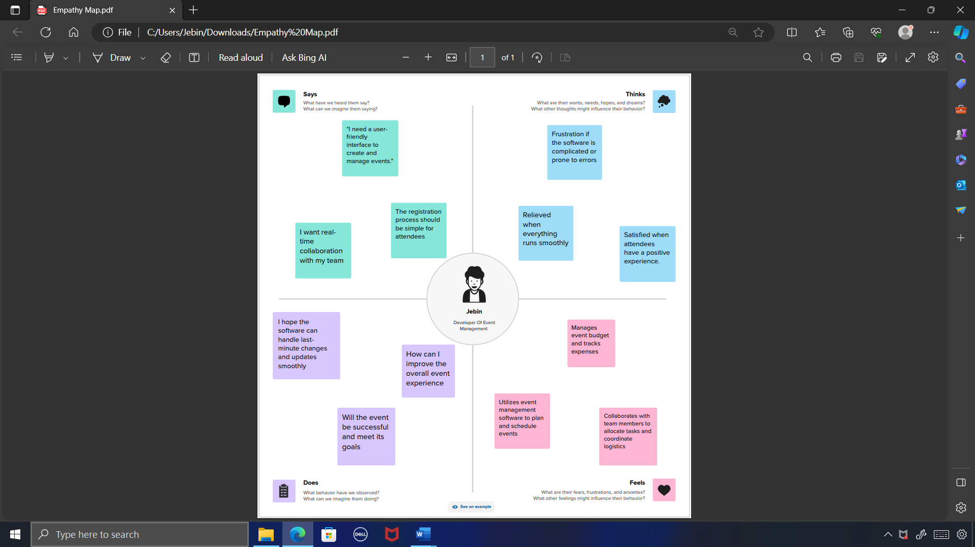

**Ideation & Brainstorming:**

Generating creative solutions to address the identified challenges, using brainstorming and collaboration.

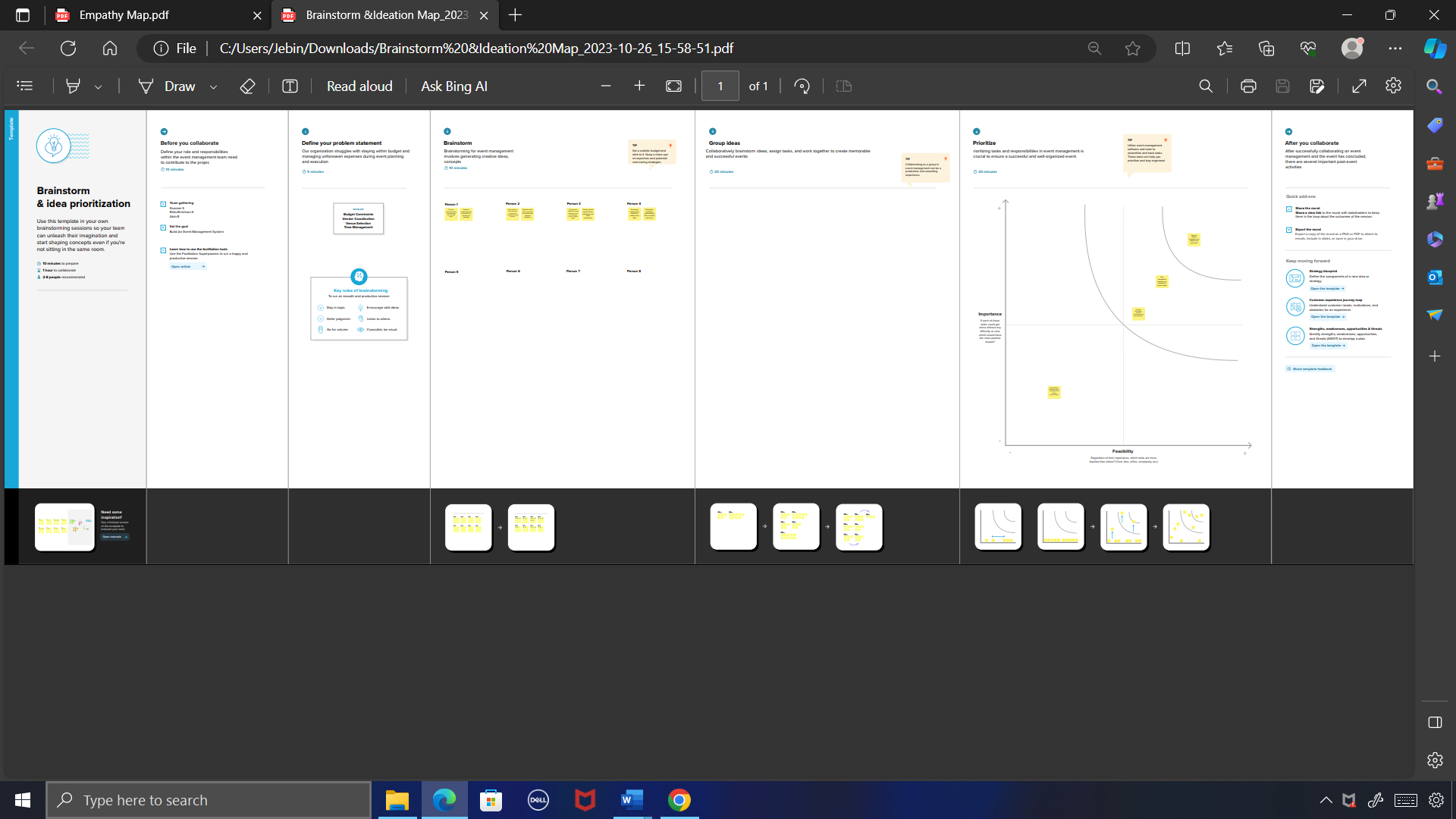

**Milestone- 01 [Creation of developer account]**

1.Go to developers.salesforce.com/signup

2.Click on sign up.

3.On the sign up form, enter the following details:

1. First name: **Jebin**
2. Last name: **S**
3. Email: **jebinjebin343@gmail.com**
4. Role: **Developer**
5. Company: **Ponjesly College of Engineering**
6. County: **India**
7. Postal Code: **629251**
8. Username: [**jebin@ponjesly.sandbox**](mailto:jebin@ponjesly.sandbox)

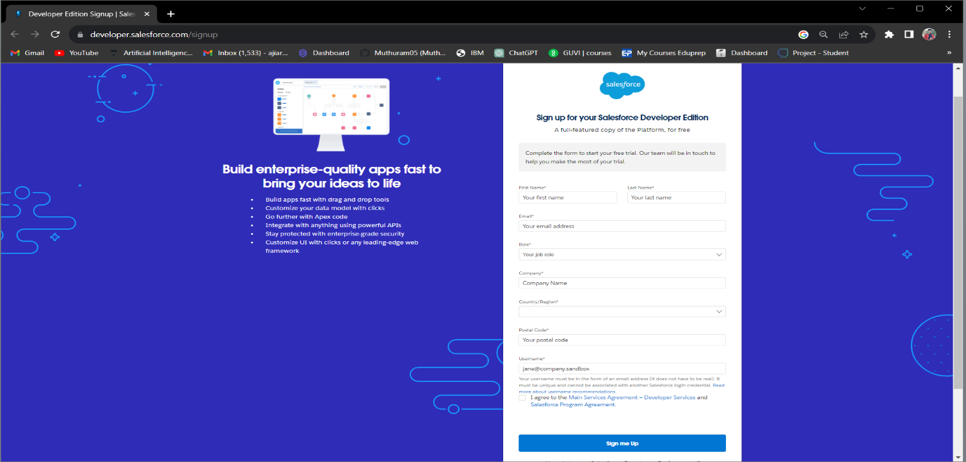

**Account Activation**

Go to the inbox of the email that you used while signing up. Click on the verify account to activate your account.

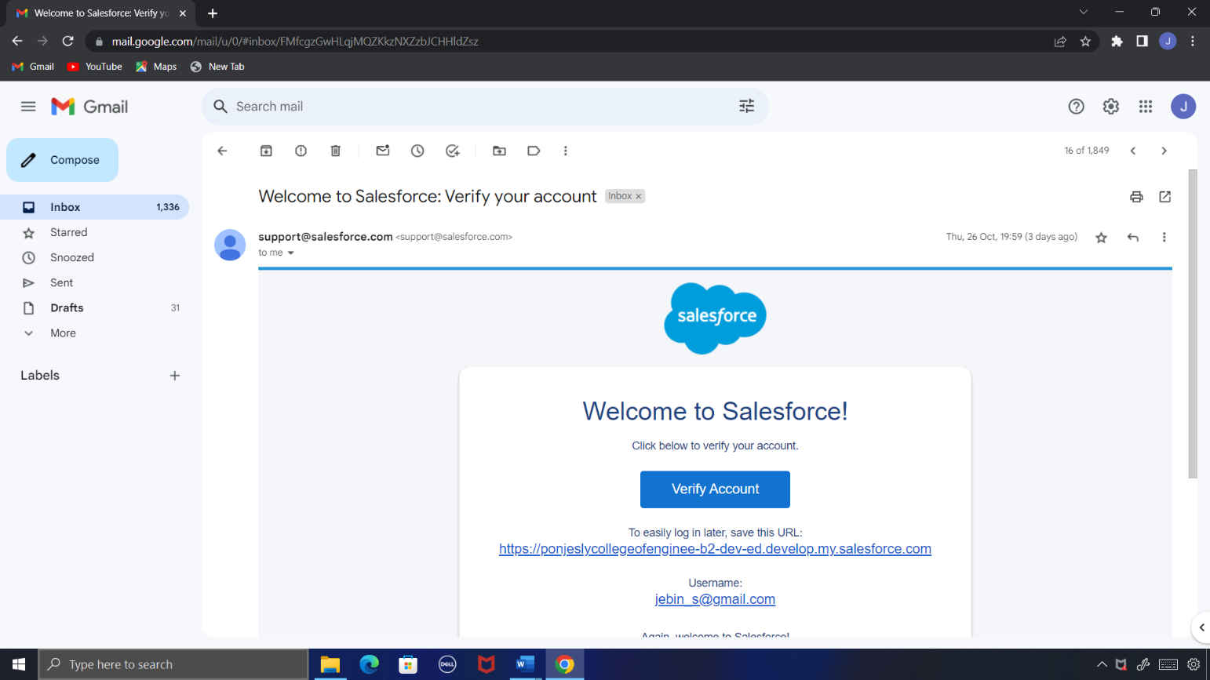

**Login to Your Salesforce Account**

1.Go to salesforce.com and click on login.

2.Enter the username and password that you just created.

3.After login this is the home page which you will see.

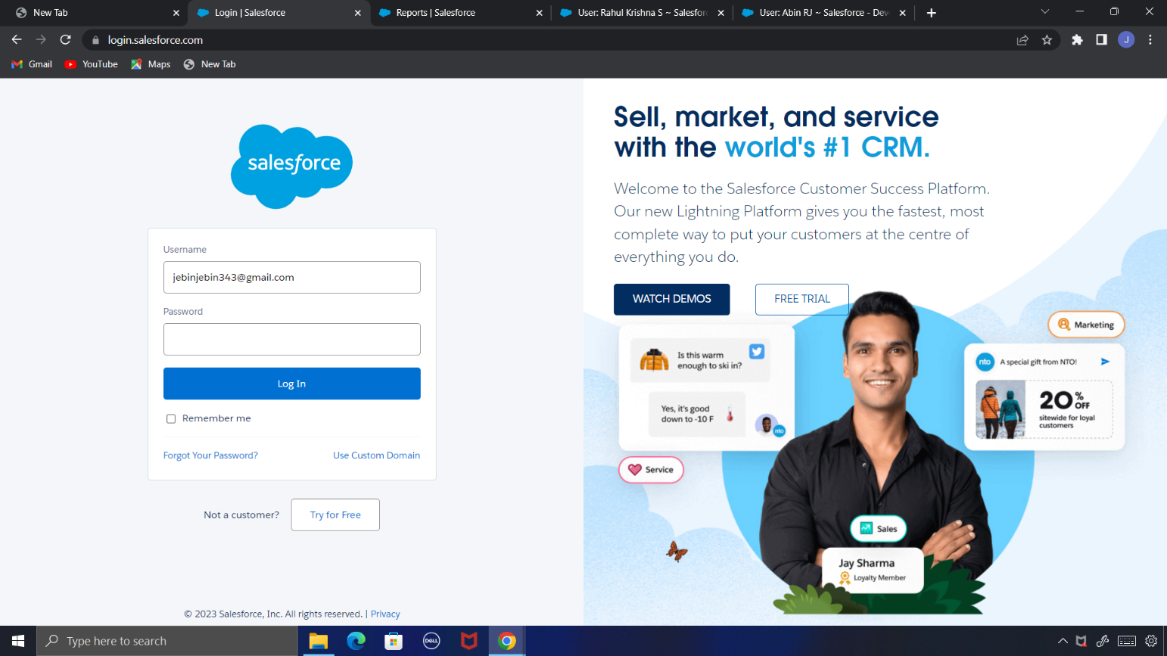

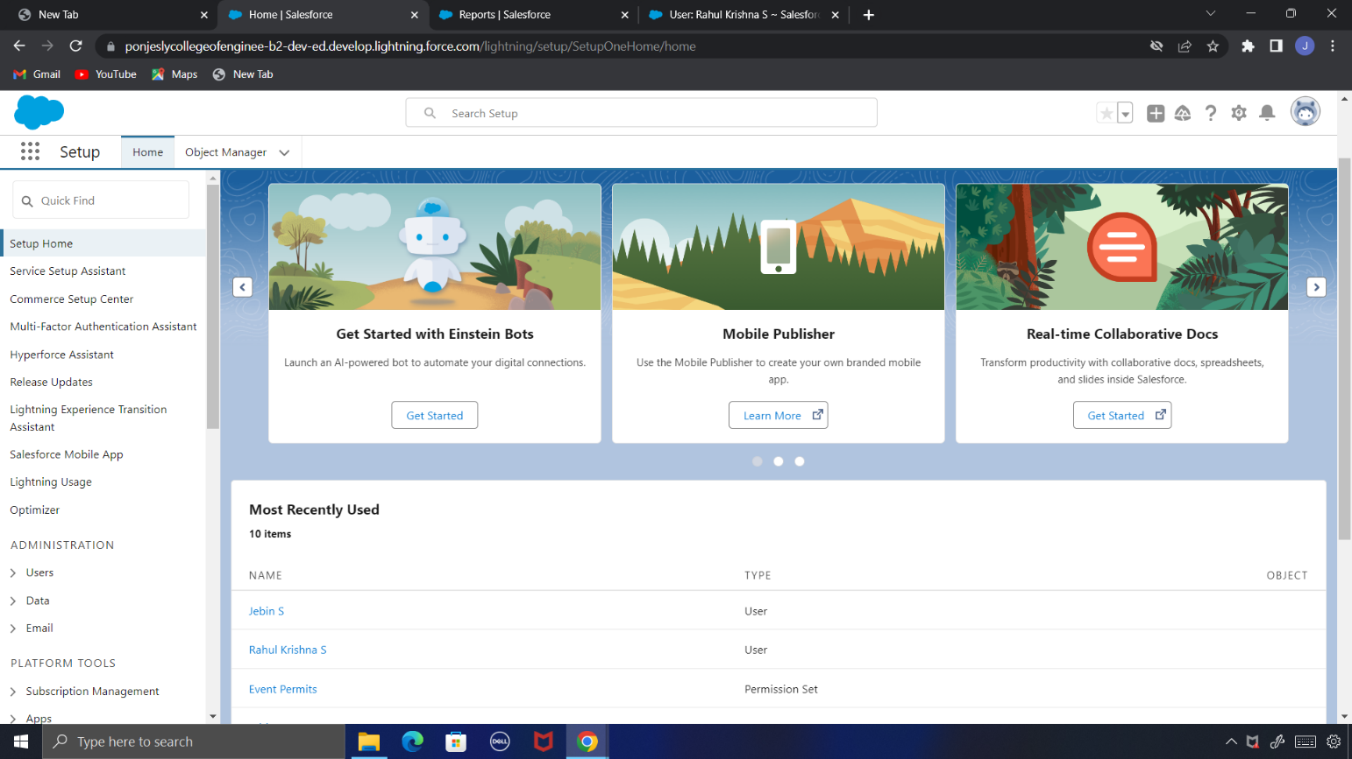

**Milestone- 02 [Object Creation]**

**Creating Custom Object:**

1. Click on the gear icon and then select Setup.
2. Click on the object manager tab just beside the home tab.
3. After the above steps, have a look on the extreme right you will find a Create Dropdown click on that and select Custom Object.
4. On the Custom Object Definition page, create the object as follows:
5. Label: **Event**
6. Plural Label: **Events**
7. Record Name: **Event** Name
8. Check the **Allow Reports**
9. Check the **Allow Search** andClick Save.

Create objects as **Event, Attendee, Speaker,** and **Vendor.**

**Object Name - Event**

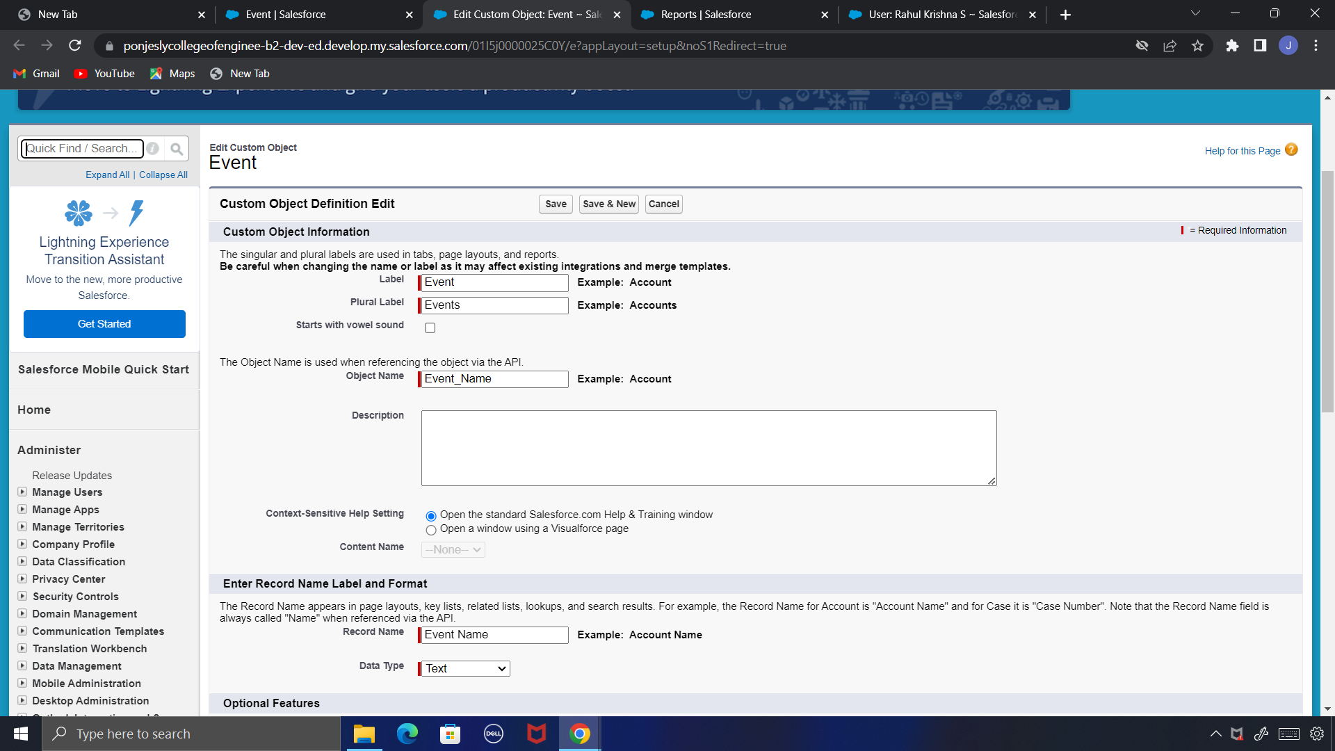

**Object Name – Attendee**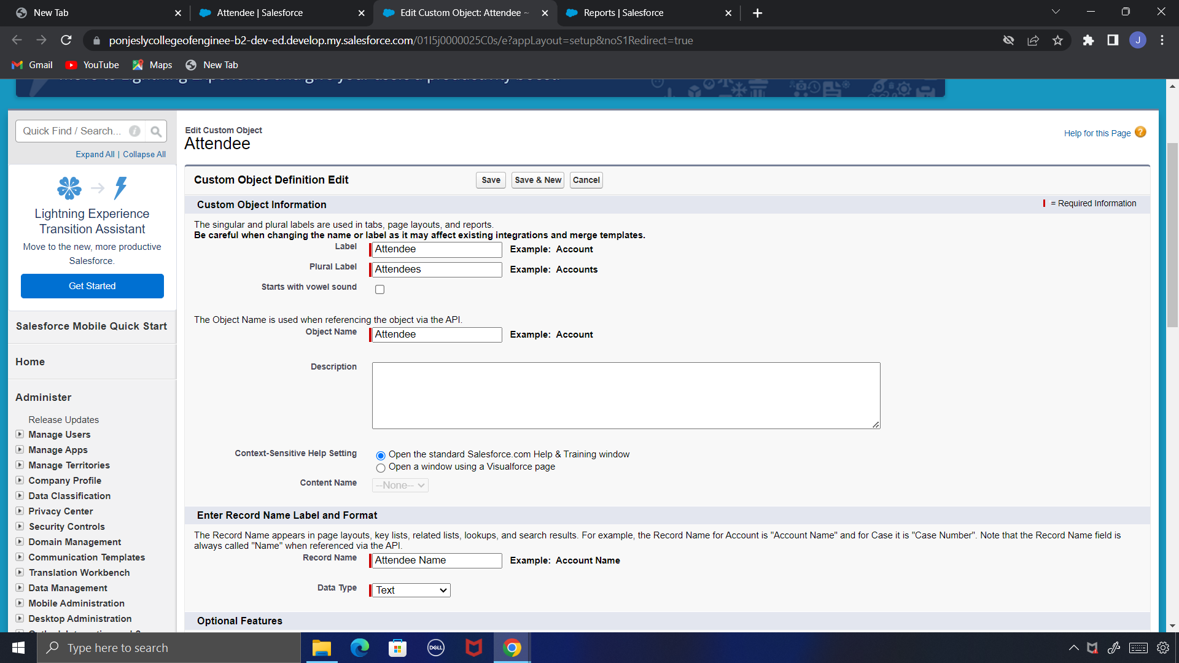

**Milestone- 03 [Tabs Creation]**

1. Enter Tabs in Quick Find and select Tabs.
2. Under Custom Object Tabs, click New.
3. For Object, select Event.
4. For Tab Style, select any icon.
5. Leave all defaults as is. Click Next, Next, and Save
6. In the same way create Tabs for all Custom Objects -Attendee, Speaker ,Vendor.

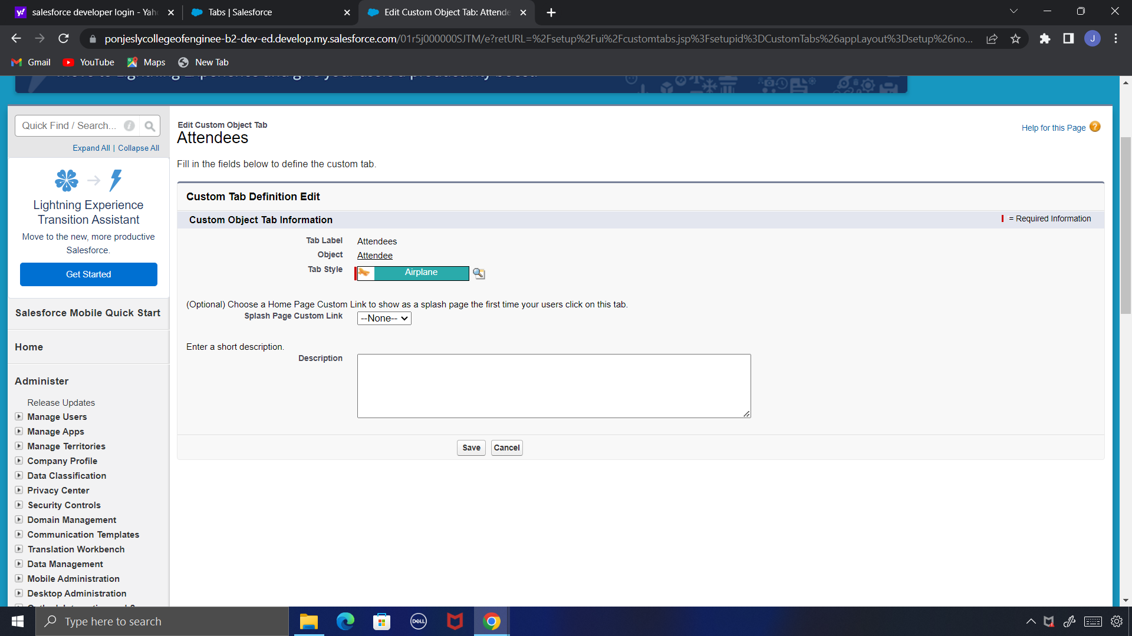

**Milestone- 04 [Create App]**

1. From Setup, enter App Manager in the Quick Find and select App Manager.
2. Click New Lightning App.
3. Enter **Event Management** as the App Name, then click next
4. Under App Options, leave the default selections and click next.
5. Under Utility Items, leave as is and click Next.
6. From Available Items, select **Event, Attendee, Speaker, Vendor, Reports, and Dashboards** and move them to Selected Items.
7. Click Next.
8. From Available Profiles, select System Administrator and move it to Selected Profiles. Click Save & Finish.

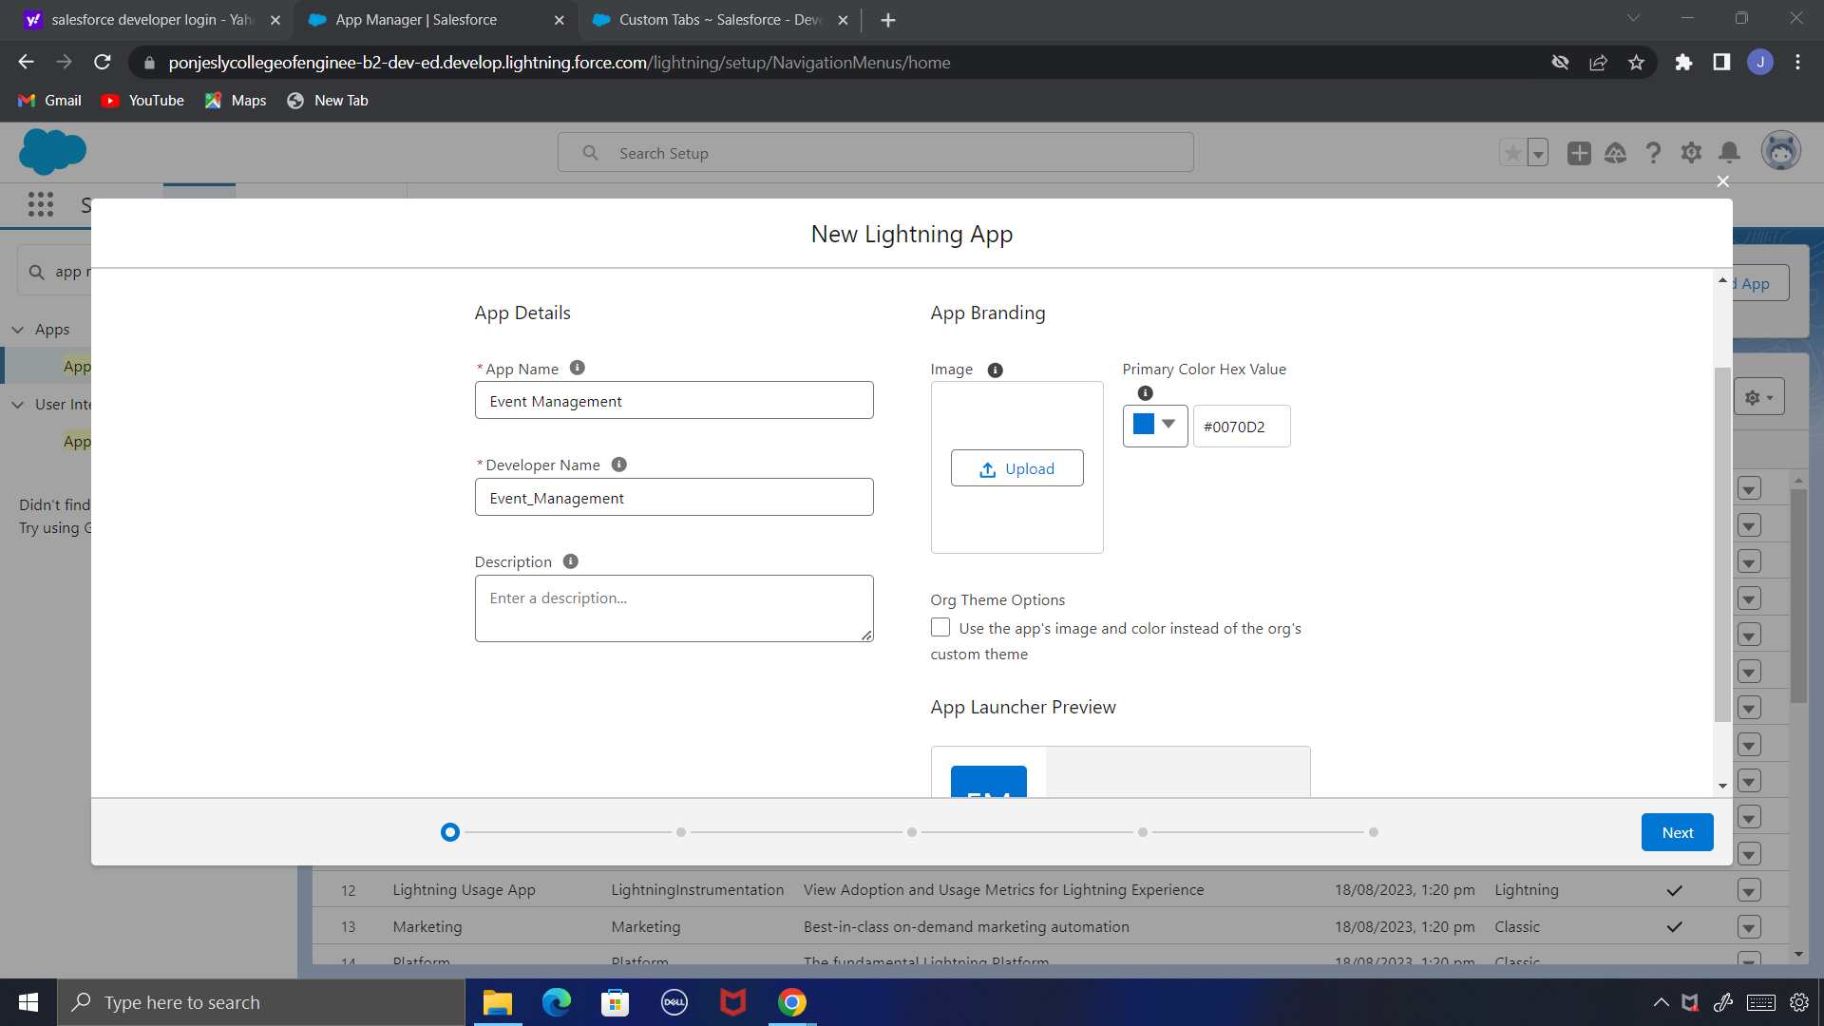

**Milestone- 05[Fields & Relationships]**

**Creation of Text Field for the “Event” Object**

1. Click the gear icon and select Setup. This launches Setup in a new tab.
2. Click the Object Manager tab next to Home.
3. Select **Event**
4. Select Fields & Relationships from the left navigation
5. Click New
6. Select the **Text** as the Data Type, click next.
7. For Field Label, enter **Event Name**
8. Enter Length 80
9. Click Next, Next, then Save & New.

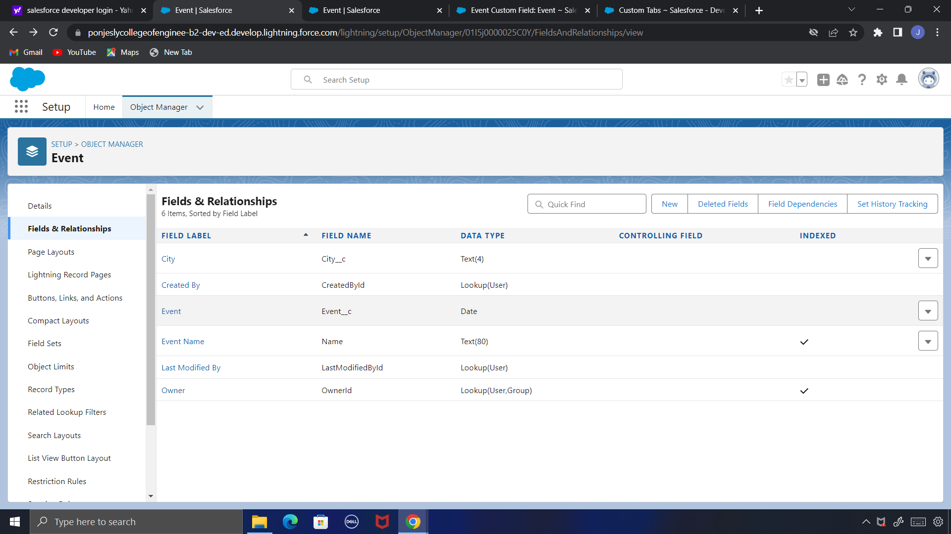

**Creation of Auto Number for the “Attendee” Object**

1. Click the gear icon and select Setup. This launches Setup in a new tab.
2. Click the Object Manager tab next to Home.
3. Select **Attendee**
4. Select Fields & Relationships from the left navigation
5. Click New
6. Select the **Auto Number** as the Data Type, click next.
7. For Field Label, enter **Attendee Number**
8. Give a Display Format.
9. Click Next, Next, then Save & New.

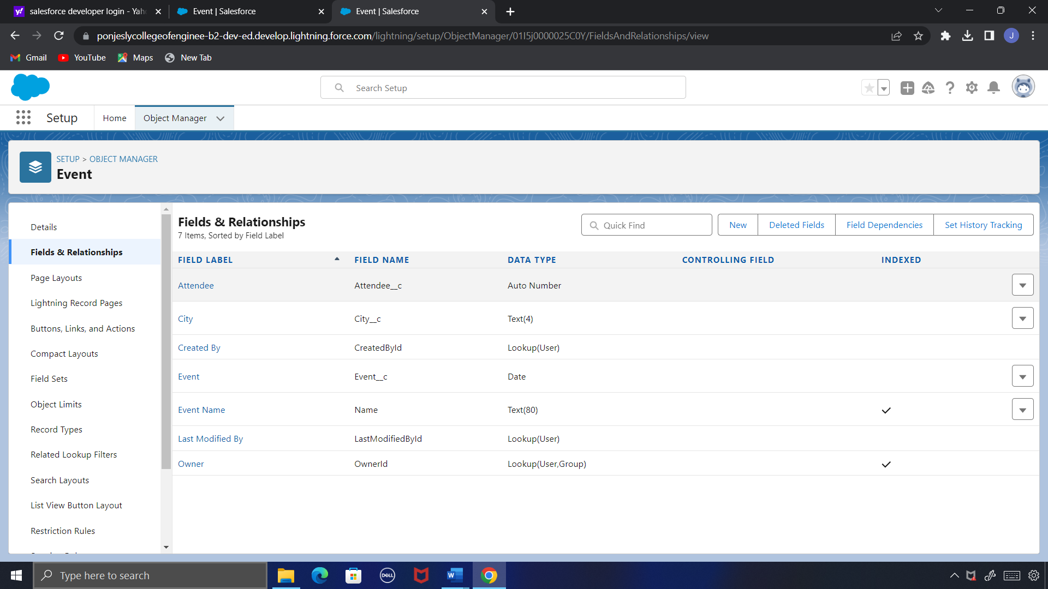

**Creation of Formula for the “Speaker” Object**

1. Click the gear icon and select Setup. This launches Setup in a new tab.
2. Click the Object Manager tab next to Home.
3. Select **Speaker**.
4. Select Fields & Relationships from the left navigation.
5. Click New
6. Select the Formula as the Data Type, then click Next.
7. Give field label **Speaker**
8. Select formula return type text, Click Next
9. Click Insert Field.

10.Click Next, Next, then Save.

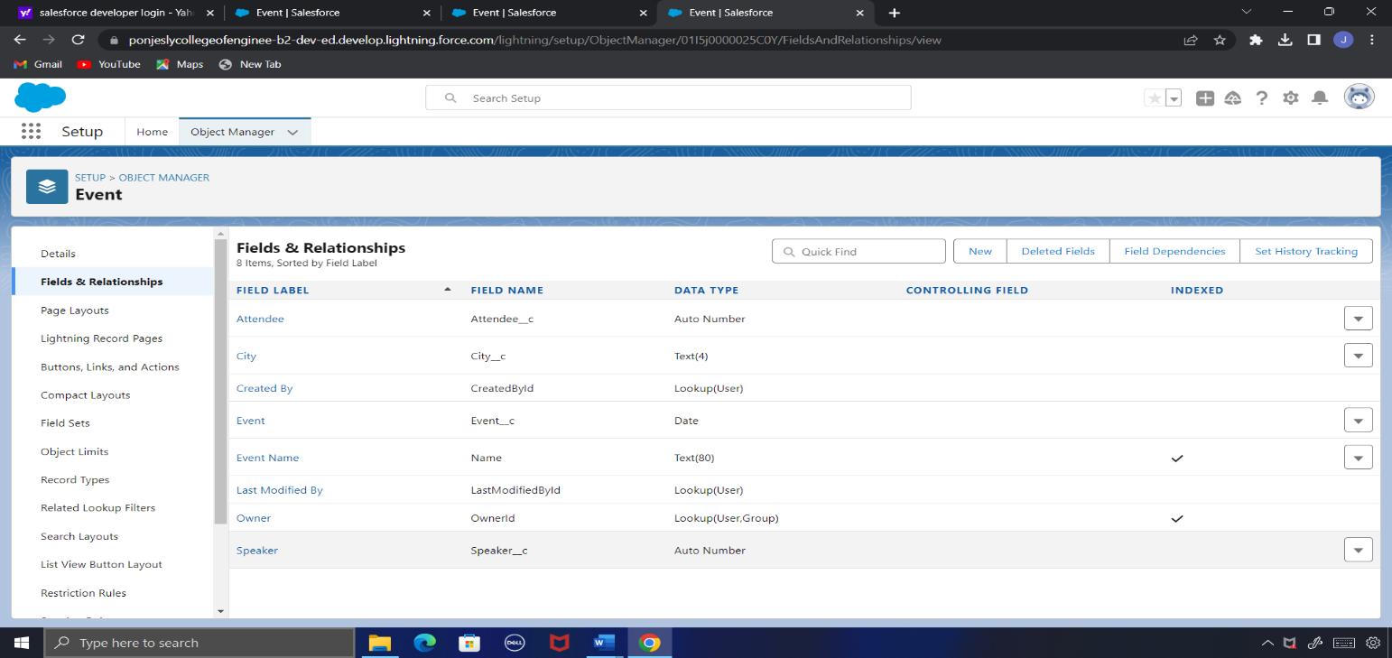

**Creation of Number for the “Vendor” Object**

1. Click the gear icon and select Setup. This launches Setup in a new tab.
2. Click the Object Manager tab next to Home.
3. Select **Vendor Detail**.
4. Select Fields & Relationships from the left navigation
5. Click New & select number field, click Next.
6. For Field Label **Duration**.
7. Click Next, Next, then Save & New.

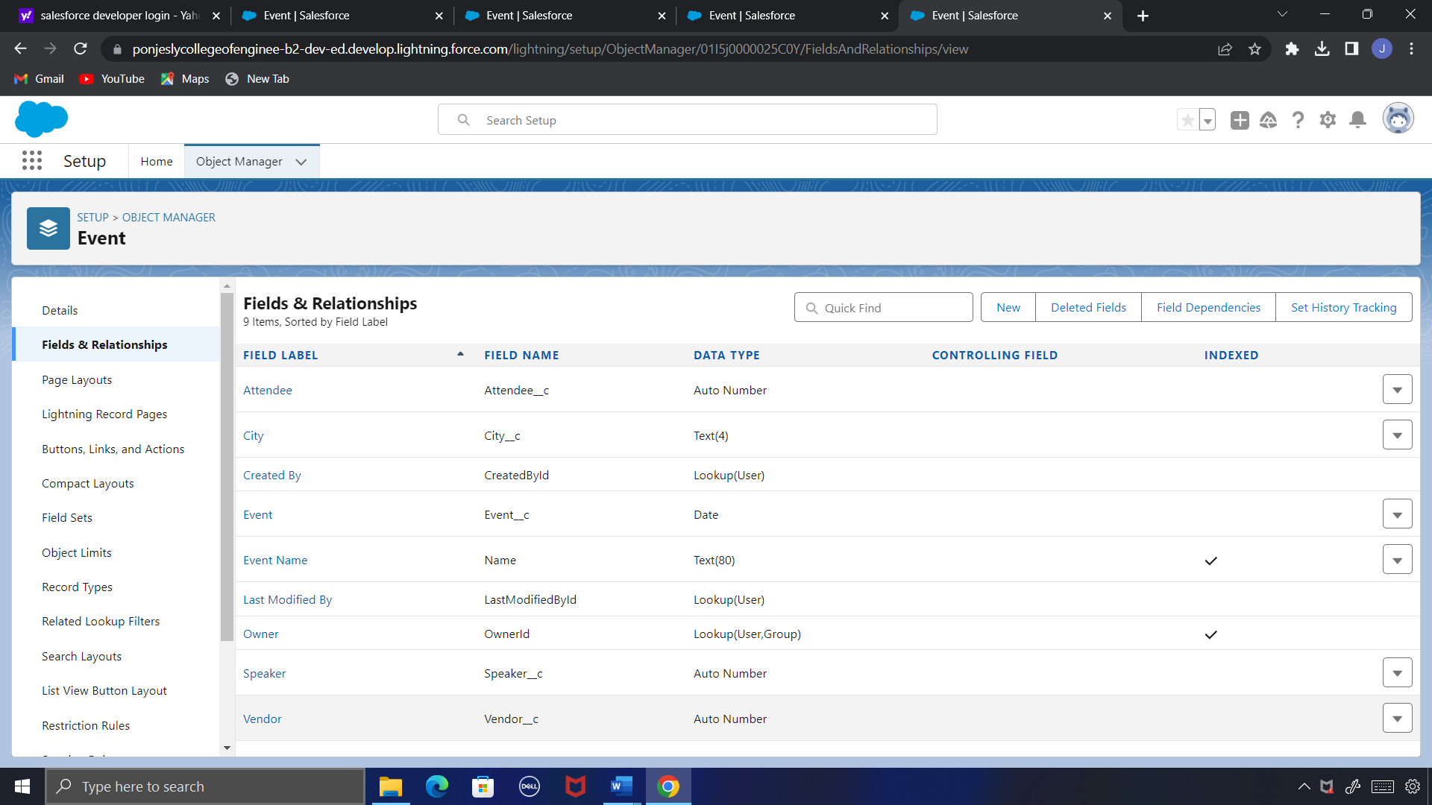

**Milestone- 06[User]**

**Creating A User:**



1. From Setup, in the Quick Find box, enter Users.
2. Select Users.
3. Click New User.
4. Enter the First Name, **email ,** Last Name, **Teacher** and (Your) email address and a unique username in the form of an email address. By default, the username is the same as the email address.
5. Select a User License as salesforce
6. Select a profile as Standard user.
7. Check Generate new password and notify the user immediately to have the user’s login name and a temporary password emailed to your email.

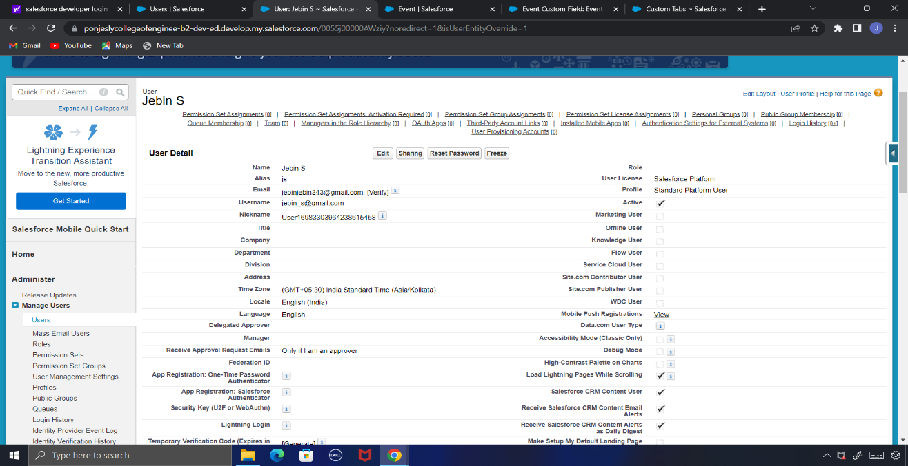

**Milestone- 07[User Adoption]**

**Create Record**

1. Click on App Launcher on left side of screen.
2. Search **Event Management** App & click on.
3. Click on **Event** tab.
4. Click new button
5. Fill all **Event** record details.
6. Click on Save Button.

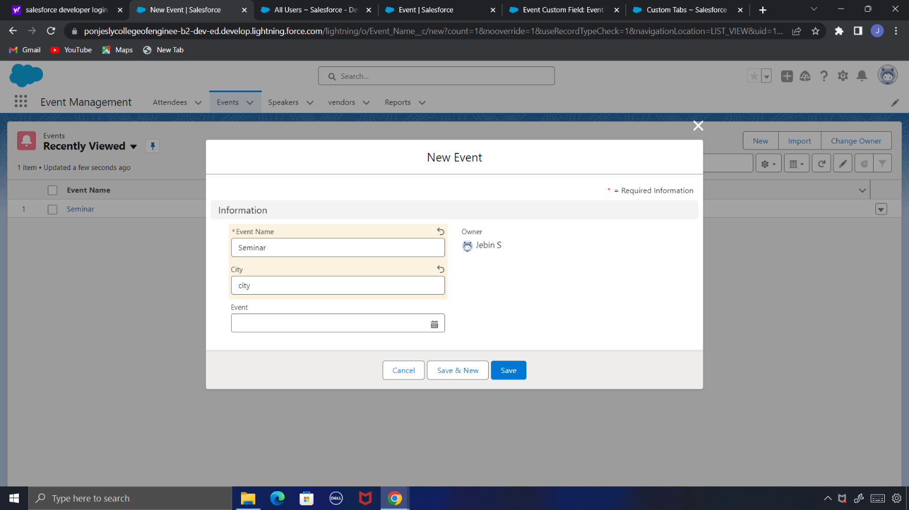

**Create Record (Attendee)**

1. Click on App Launcher on left side of screen.
2. Search **Event Management** App & click on.
3. Click on **Attendee** tab.
4. Click new button
5. Fill all record details.
6. Click on Save Button.

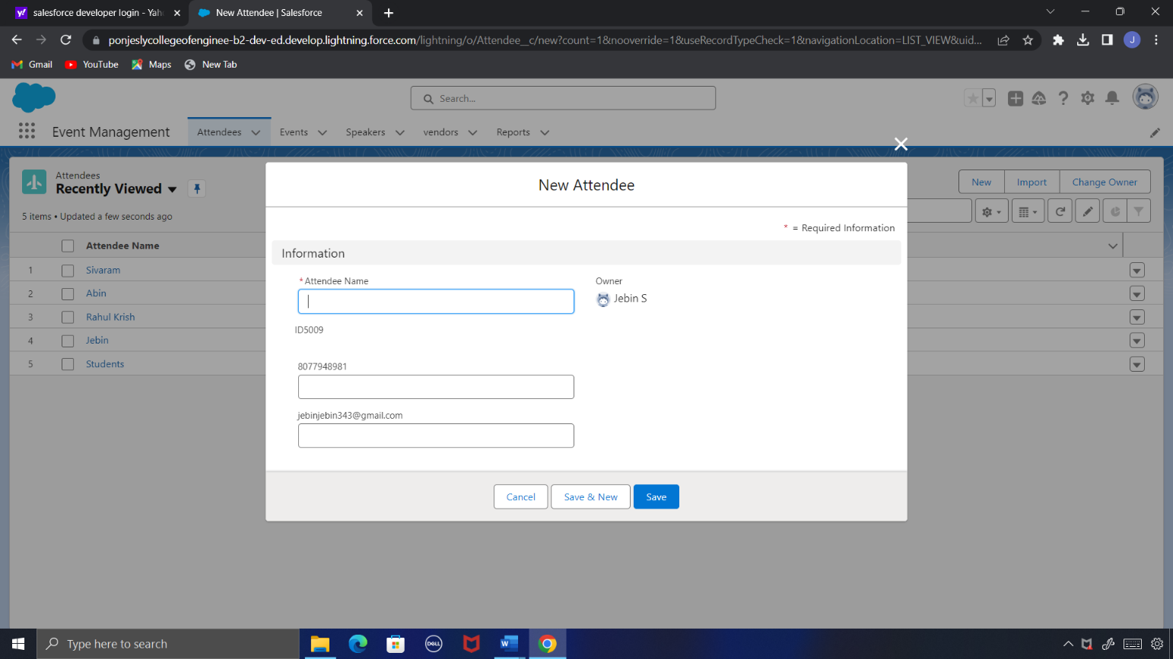

**Milestone- 08[Reports]**

1. Click App Launcher
2. Select **Event Management** App
3. Click reports tab and click new.
4. Click the report type as Speaker with Attendee Click **Start report.**
5. Customize your report, in group rows select – **Attendee Name**, in group column Select **email and number.**
6. Click save and run
7. Give report name –**Event Report** andClick Save.

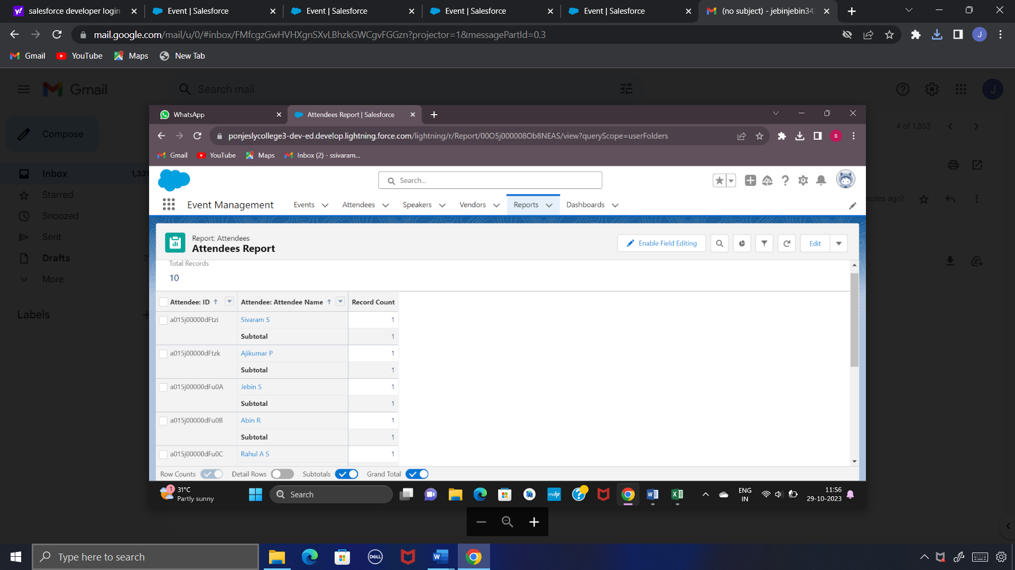

**Milestone- 09[Dashboards]**

1. Click on Dashboards tab from the Candidate Internal Result Card App.
2. Click on new dashboard.
3. Give name- **Event Management** and create.
4. Give your dashboard a name and click on +component
5. Select the **Attendees Report** you created.
6. For the data visualization select any of the chart, table etc.
7. Click add and save.

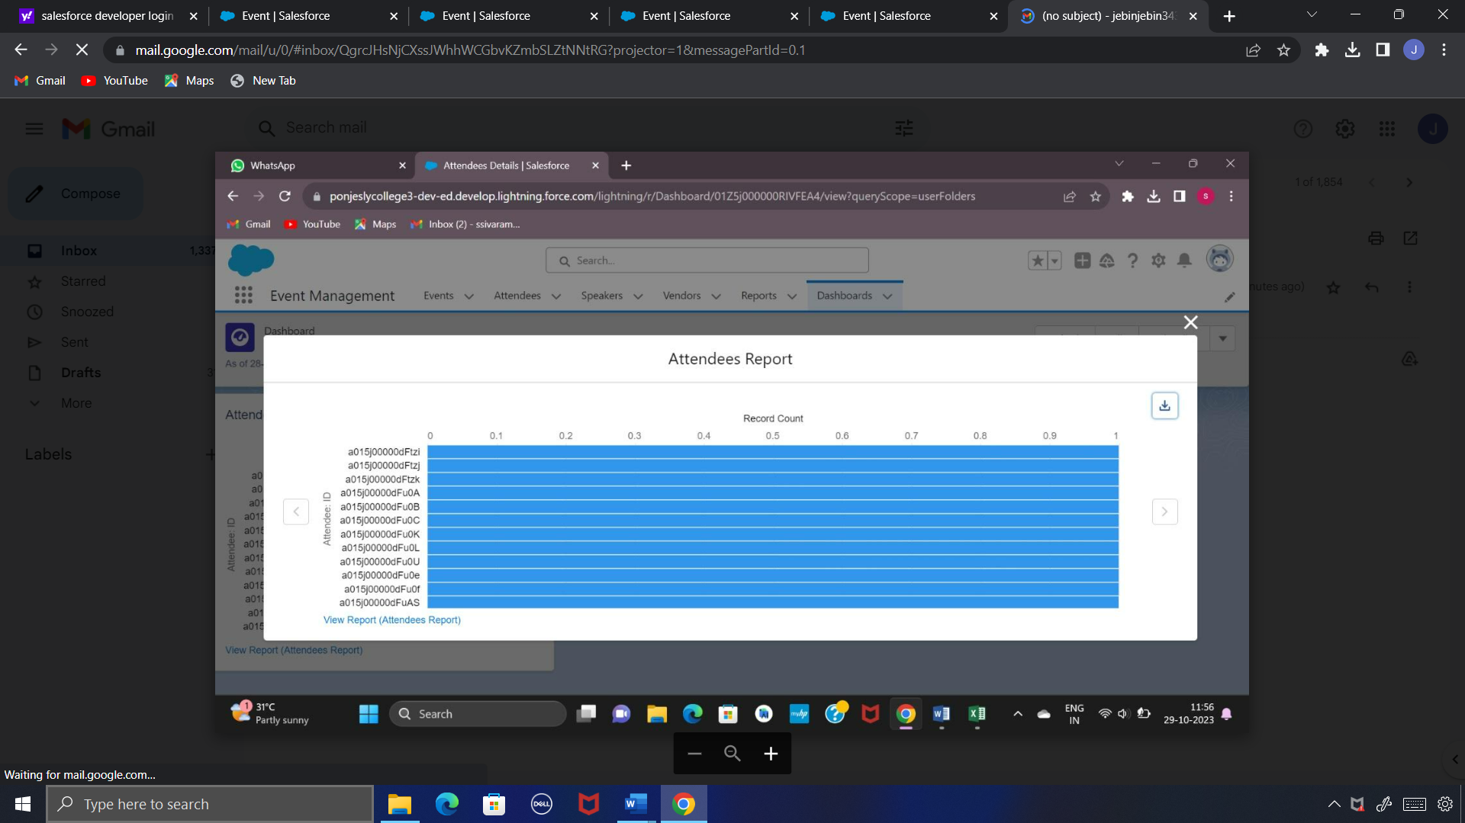

**Milestone- 10[Screen Flow]**

1. Click on Gear icon and select setup
2. In Quick find Box enter flow and select the flows
3. Click on New flow and Select Screen flow
4. It will open the canvas. Select (+)
5. Select the screen element from the drop down.
6. It will open the dialog box. Now give the label **name Event info.**
7. In search Component type text and drag the text component to canvas and give the label **Event Name**
8. Select (+) and Create records and select the create records
9. Give Label as **Create Event Records.**

10.Then check the use separate resources and literal values

11.Search for candidate object

12.Under field type name and select the **Name** and select the

**Event_Name.**

13.Click on Done and Save.

14.Give the Flow Name as **Event flow** and Activate.

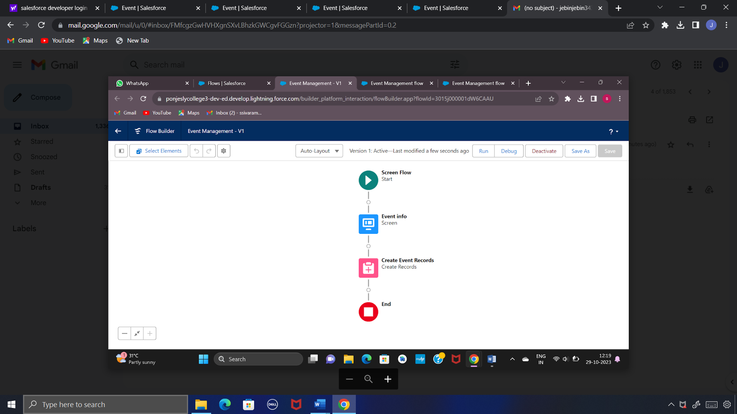

**Milestone- 11[App Page]**

1. Click on the Gear icon and select set up
2. In Quick Find Box Type App Builder and select the lighting app builder and Select New
3. Select the App page and click on Next
4. Give the label Name as **Event App page.**
5. Select the one region and click on finish.
6. Type the flow in the search bar and select the flow component and drag the component
7. After dragging the component, give the flow label as **Event Flow** click on activate.

Demo Video Link:

Trailhead Url:

Team Leader: Sivaram S

<https://www.salesforce.com/trailblazer/sivarams>

Team Member1: Jebin S

<https://www.salesforce.com/trailblazer/jebins>

Team Member2: Abin Rj

<https://www.salesforce.com/trailblazer/abinrj>

Team Member3: Rahul Krishna

[https://www.salesforce.com/trailblazer/](https://www.salesforce.com/trailblazer/shajikj)rahulkrishnas